WEB DESIGN
PROJECT REPORT

PROJECT TEAM
Student No. | Student Names
X19184221 | Daniel Escott
X19141815 | Ronan Behan

DemGainz Gym

demgainzgym.netlify.com

Overview

The name of our website is DemGainz Gym.
Our idea for this project was to come up with a website for a fictitious gym. The gym culture has taken hold in this country so I and Daniel saw great potential for commercial experience here. It was also an opportunity to collaborate on a project that we both found enjoyable, please note the tongue in cheek nature of the website, and fascinating.
We had a few ideas at the start, the most prominent being an alcohol delivery service but our group of three, Daniel, David and Ronan were reduced to two when David left the course. This was tragic and a great strain on our resources but we came together again and came up with this fun and interactive website.

Section 1: Design

Research / Investigation

Competitor number one.
Fly fit. This a major Gym in Ireland with many locations in Dublin and it recently moved down to Cork.
I really loved the simplistic design of this website with the nice collage of pictures to help liven it up. The dark background and the bold white writing were a big influence on me. These colours denote stability, security and a sense of alertness and wellbeing. These are the qualities that we seek from fitness centres.
This simplistic outlook of the page seems very in vogue at the moment and Fly fit’s page is a joy to navigate through.
One criticism would be that perhaps they have too much information, too much writing on the first page, where we would prefer to put this in the content.
Another criticism is that they have no Home button, you only click on their logo, and this could be confusing to the older generation. We must think of our customers.
We also took a lot of interest in their “nav” bar as it was to the point, stylish and contained all that was necessary.
Competitor number two.
This would be the website of Anytime Fitness. It is one of the biggest chains of commercial Gyms globally.
We didn’t really like the feel of this website as it doesn’t seem to be user friendly. The “nav” bar is short and leaves a lot to be desired. The links are all over the place. It doesn’t really have a friendly feel to it.
I liked about it was the video in the background of happy Gym goers enjoying time with the staff.
I like their offers, as they are straight in front of you as you enter.
I did also like their JavaScript in the fact that it asks you for your location to help you find the closest gym to you.
Competitor number three.
Gold’s Gym. Need I say more? This institution has been a paragon of fitness and perfection for quite a long time now. Arnold Schwarzenegger being the poster boy as well as many other celebrities. It stands alone. Its name exudes confidence.
I like their marketing approach. It is of happy gym goers enjoying life. Happiness and comfortable clothing. It speaks volumes.
The fact that they have an active blog is very impressive. It shows that they are in tune with their clients and always looking to bring them the best information so that champions can be born.
The footer is great too. It is clear, massive and contains links to almost anything you can think of, most importantly all of the social media outlets.
The product placement in all of the pictures is definitely something that must be recreated by any business that wishes to survive.
We really enjoyed their experience pages as these contained promises b the company, giving it some credibility as they would have to live up to those promises.
The pages are bright, lively and inviting. It was a joy to research this page as it was quite an inspiration.
How can your team better approach your own website, having looked at the competitors?
Having done some extensive research on these websites we can take a lot from them. In particular Fly fit as it is a major part of our lives and our first insight into Gym Websites.
The majority of the ideas I took from Anywhere Fitness was how not to create a Webpage, it felt so mechanical and uninviting that I endeavoured not to recreate this this feeling in my website. Although I really appreciated their background videos.
I loved Gold’s Gym’s Website as it felt like a breath of fresh air.

Requirements & Technical Approach

6 HTML Pages

We will use 6 pages to advertise our service. Naming the home page index.html so that the website would launch. We want the pages to promote our service and we will also include a contact page where customers have the opportunity to contact our email address through the use of a form. The form is also a requirement.

CSS

To style the website we will deploy CSS. It is a requirement to use one external file. This links to all 6 pages of HTML through the one CSS file.

Navigation System

To provide an enjoyable user experience we have planned to use a nav bar at the top of the home web page, that links all pages in the website and is clear and easy to use. We will use the same navigation bar on each page for consistency.

Responsiveness

We have planned to have the website look and function well across all mediums by writing CSS for different media query scenarios.

JavaScript

We are required to use 4 examples of JavaScript and have planned to include alert pages when entering the web pages as well as the form on the contact page.

Website Deployment

We plan to use GearHost to deploy the website.

Sitemap & Wireframe

Sitemap
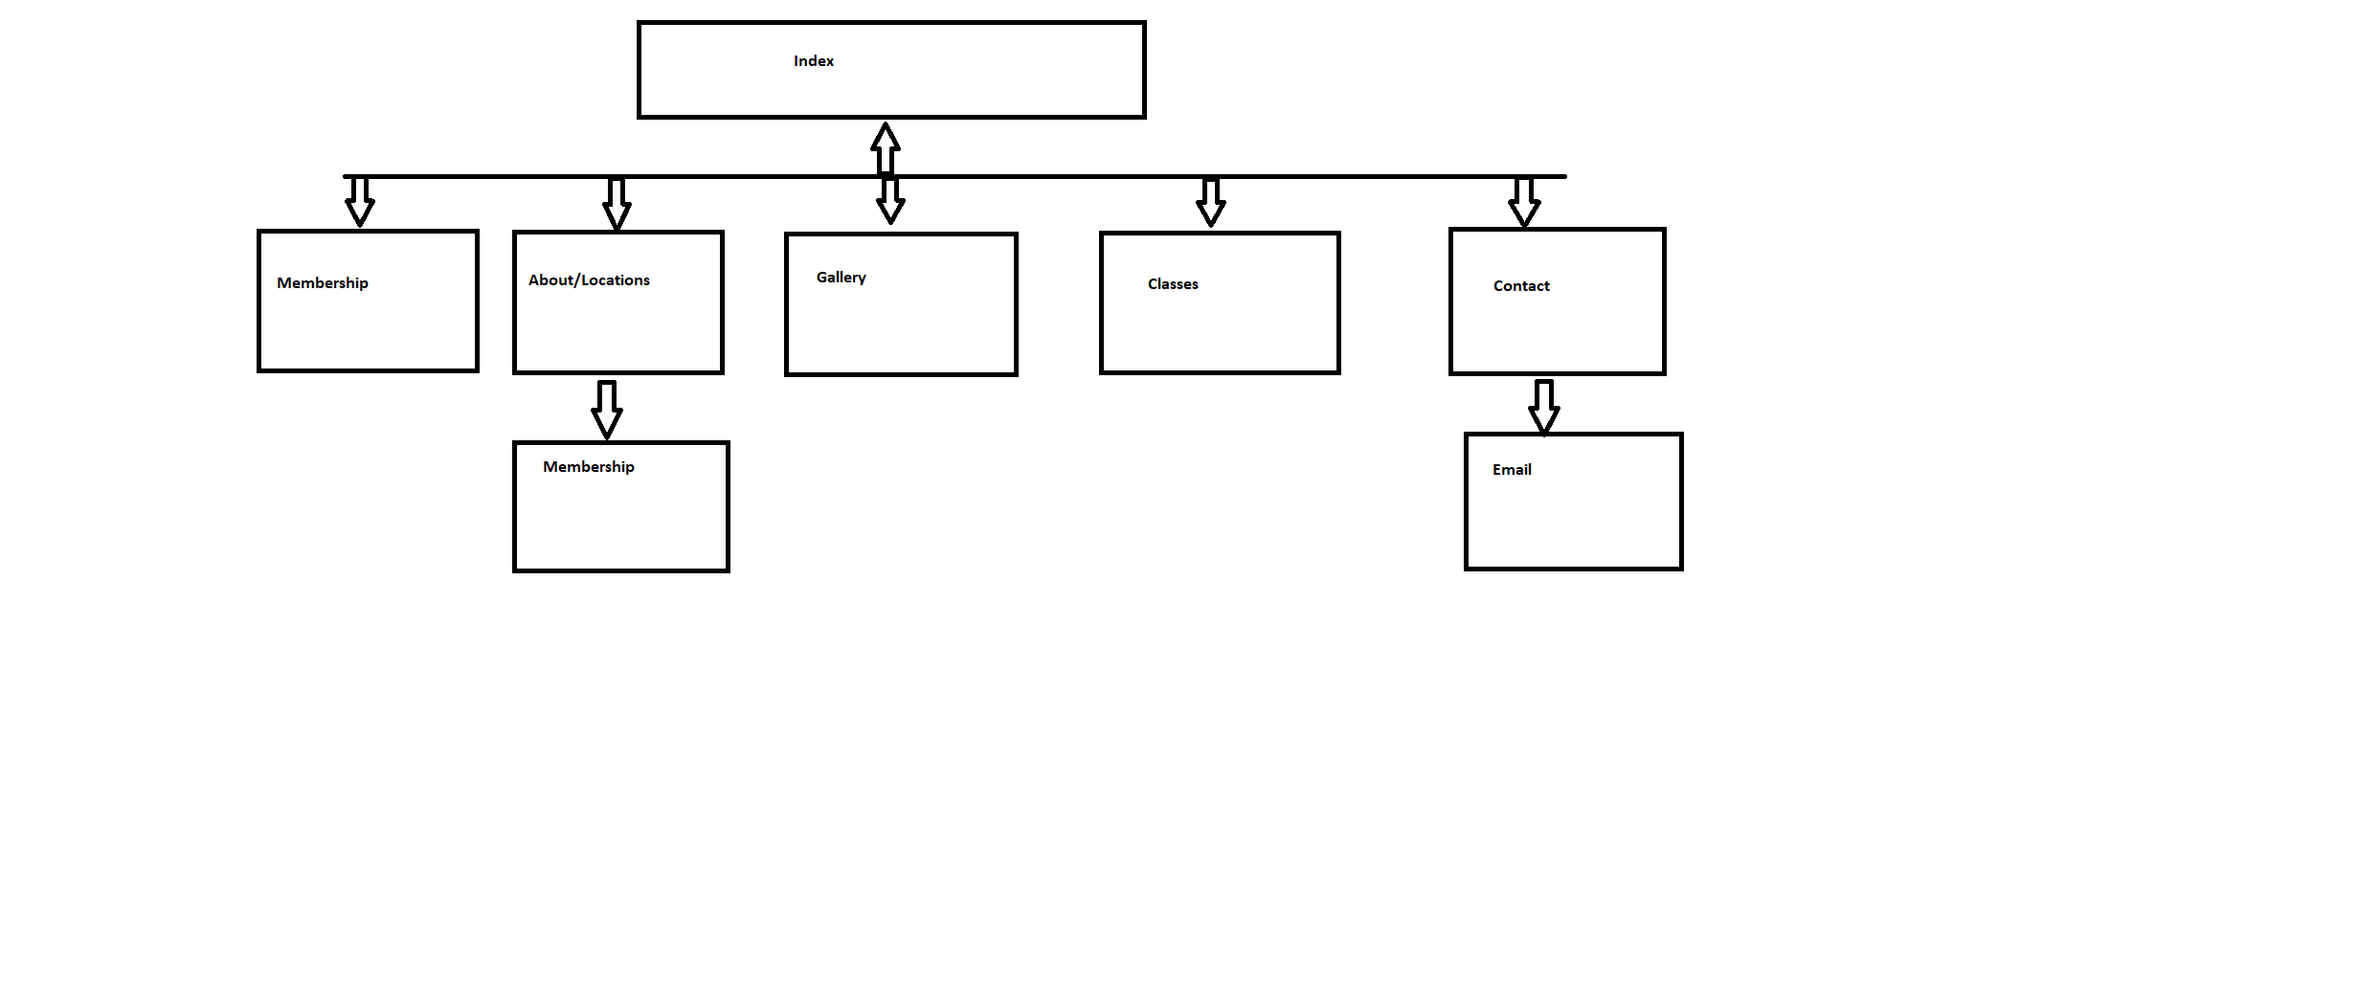
Our Site map is simple in function but allows the user enter any page from there current page and allows the user to enter the membership page when they choose a location.

Wireframes

Index

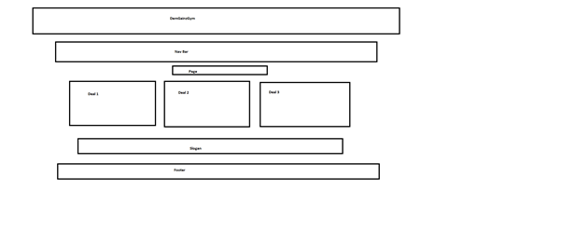

Membership

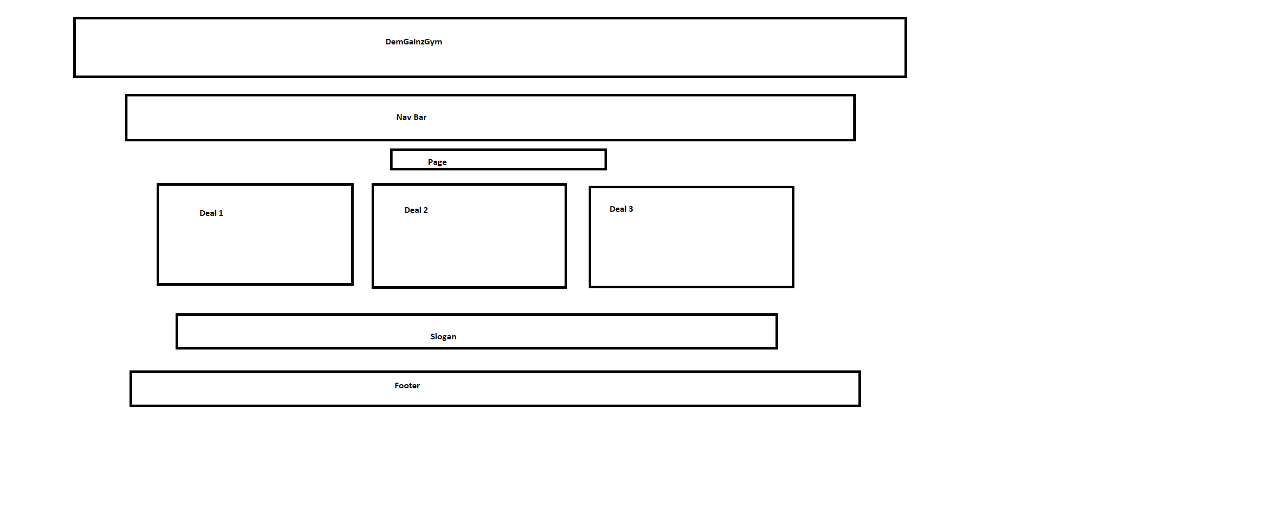

About/Locations

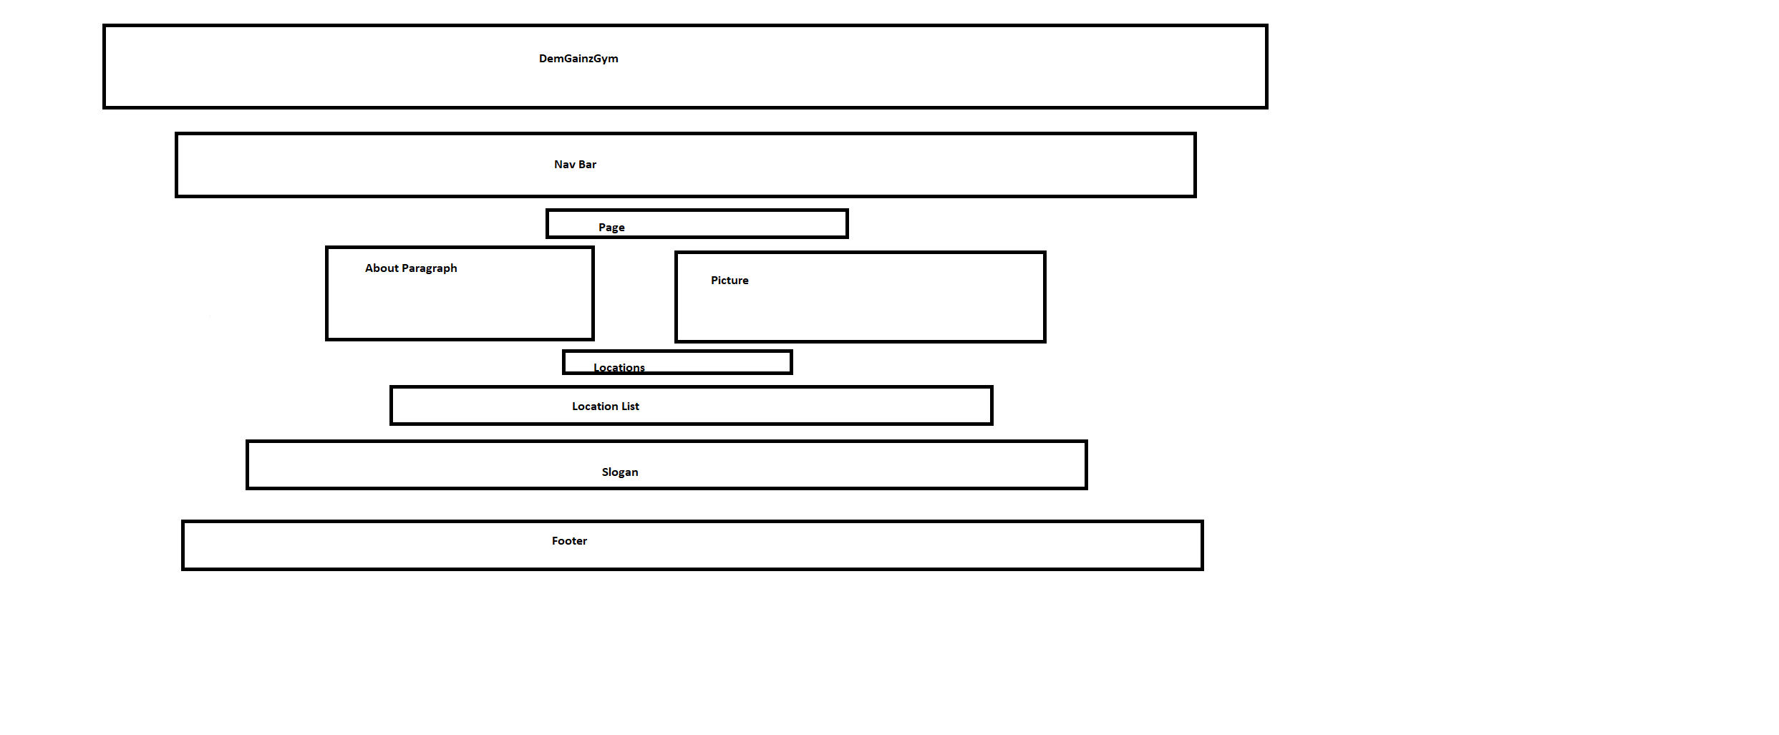
Gallery
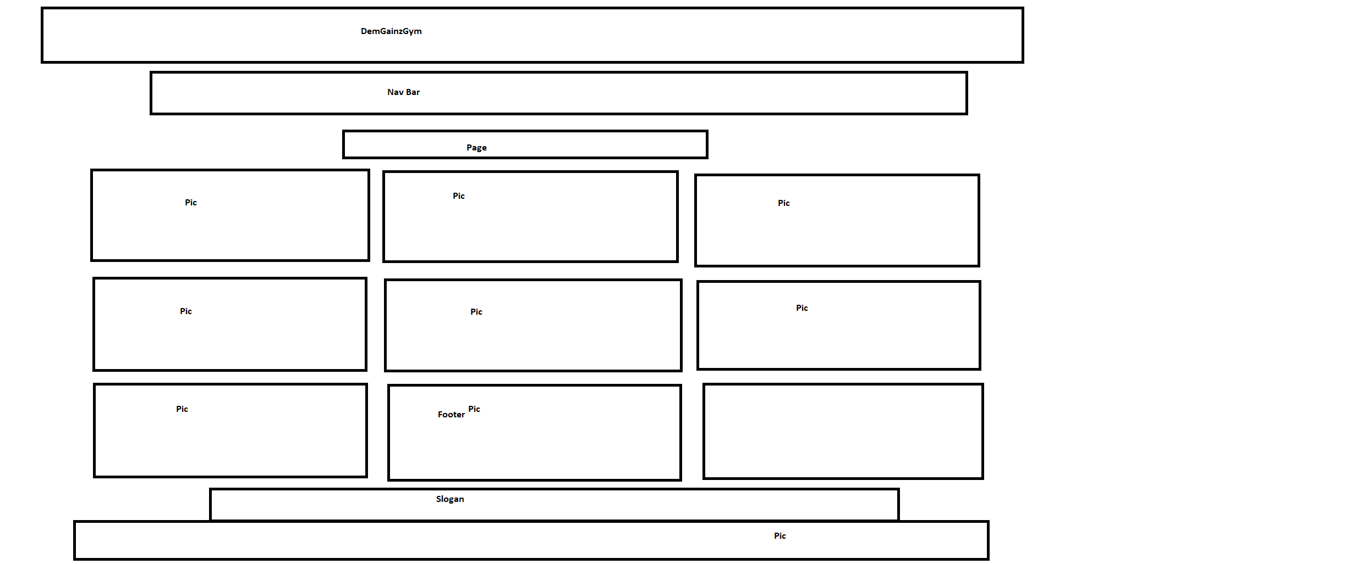

Classes

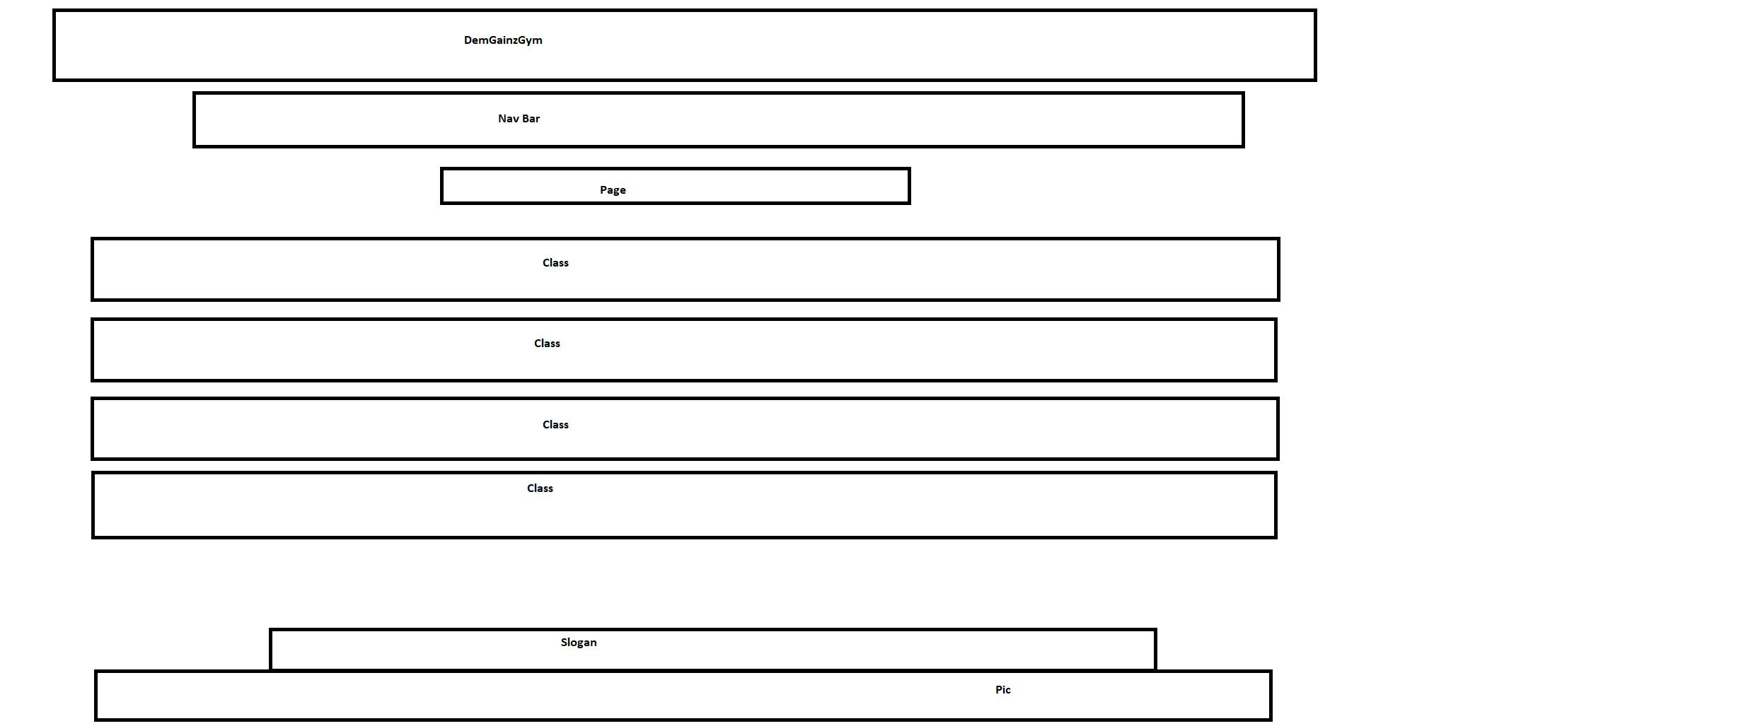

Contact

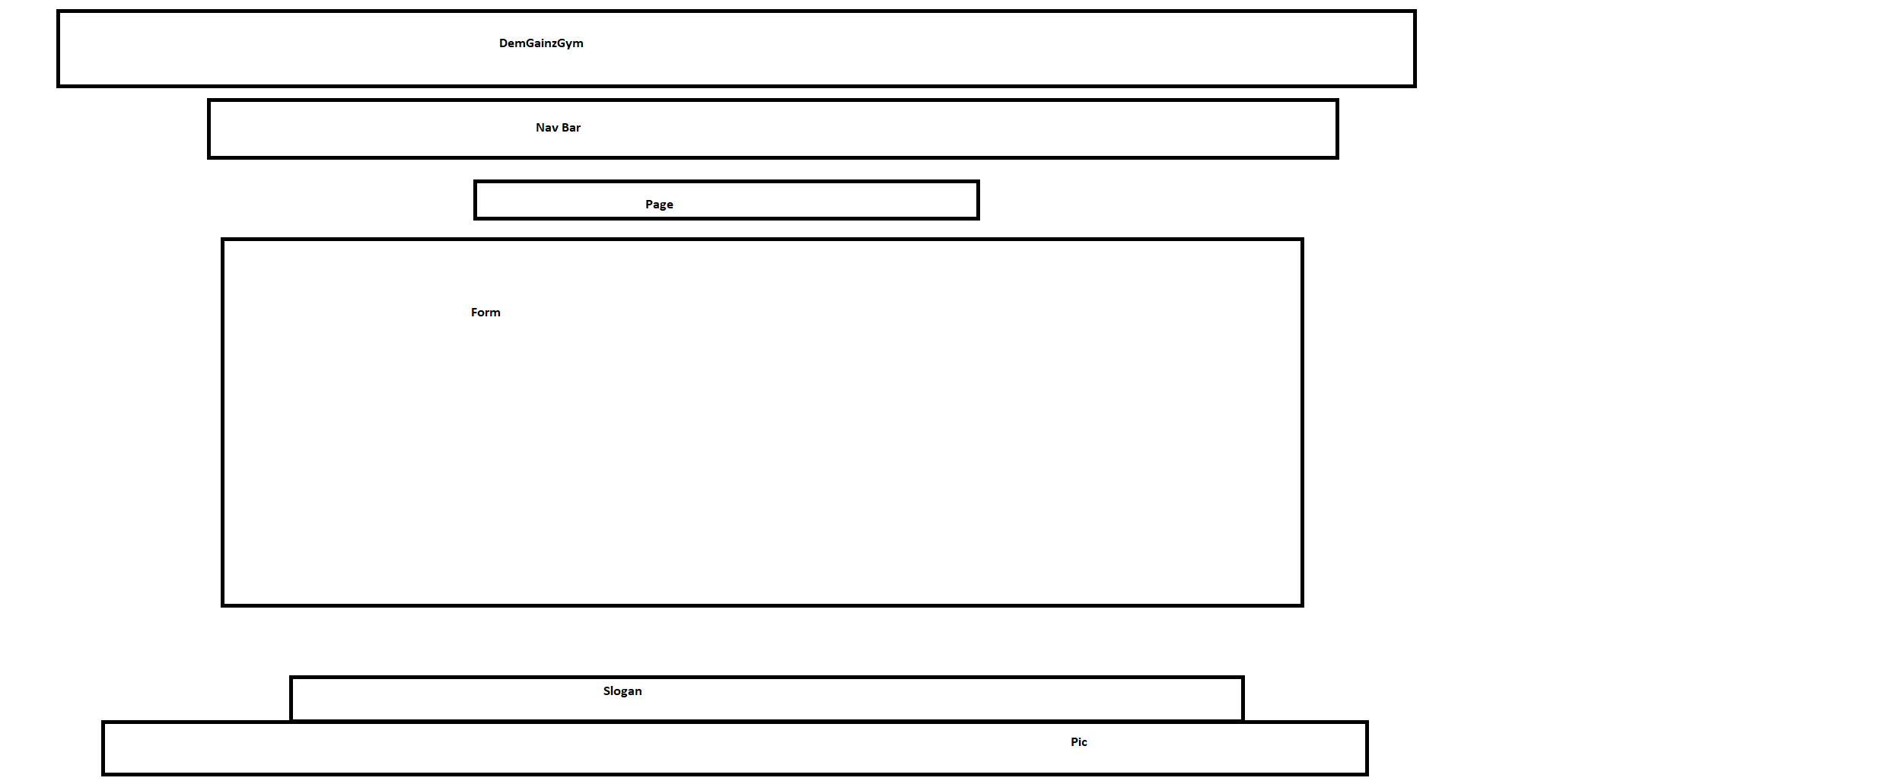

All of the wireframes were designed so that the website would have a consistent appearence with the content in the center of the page being the only thing that changed depending on what we wanted to show the user. It is a simple design that we hope will allow us to clearly define the different sections of the HTML, which in turn will hopefully give us a low error count, and the ability to spot errors easily.

The page is classically laid out with the name of the service at the top followed by a navigation bar so that the user can easily see how they will be using the webpage.
This is followed by the page name and the content of the page with the footer closing out the page a the bottom.

Section 2: Development

Ronan’s Part

Before I began, I wrote down a list of tasks for me to do such as create a nav bar or footer. With this list I went from task to task in an orderly fashion. It really helped me concentrate and not get too confused or frazzled.

Before we began, we created wireframes and created a plan of how to proceed.

I started by creating a CSS Selectors Reference at the top of my page this was to assign properties to everything on the page. This was to avoid the preordained default settings. I like to choose my own path. Here I also applied the text style: 'Open Sans', sans-serif. This writing gives it a funky feel while staying formal.
Next, I went to the body to clear out the margin, give a background colour. I applied “margin: 0 auto;” to keep the website I the middle of the page. Then the width to make the website take up 95% of the screen. I also applied the max-width and min width to make sure the content doesn’t get too concentrated together if the screen size changes.

The next I did was h1. This is the main heading of the page where the large name of our gym is displayed. Here I made the colour blue, made the writing 70px, turned it white, put in padding and centred the text.
The next few divs focused on the nav bar. We definitely wanted one of these as they look so sleek and elegant. These make a page very usable. I made the colour a medium dark grey. This made it very professional looking. I wanted the text to lean to the left as I wanted the nave bar to be available for later development. I took away the “list-style-type”, added “overflow: hidden” to assume better control of the web page. I displayed it in a block to make it look better, I added padding to the sides.
I added “li a:hover” so that when the cursor is over a word in the nav the area around the word turns darker. It’s a cool little trick that makes the website feel more responsive.

Next, I worked on h2, this was to display the word of the menu you are currently on. I put a bright Cyan background to this, put it in a block and added some padding, fixed the margins, created the perfect width for a good clean look and put it in a border, coloured the same as the nav and the footer. I think it is eye catching and suits the colour scheme.

Next, I moved onto the footer, I changed the colour to the same as the main heading and the border of the page name block. I created Margins to centre the text. I set it as fixed so that it would always stay at the bottom. I just think this looks fabulous. I set the bottom to 0; to keep it stuck at the bottom of the page. I aligned the text to the centre and fixed the height to 30px.

I started working with all the pages in mind as a good CSS base would work for all, then I went on to do work with specific pages in mind. Next, I will talk about the work I did on the specific HTML pages.

The next section is the offers from the membership page. I wanted them in boxes side by side displaying the headings of the deals. To do this I also had to go into the HTML and change some of the headings around. I brought them down by using <br/> in the html pages. I also centred the slogan.

I think it was a very good idea for Dan to do up the skeleton in HTML and then I went in to fix it up, make it work and look really fresh.

At the end of the CSS I put in several different instructions for Media Queries to help make our website more responsive.

After this work and it was much work I went back throughout the individual HTML pages to make them look better and suit the new CSS even better.

Finally, I worked on the 2nd, 3rd and 4th JavaScript. I just put these in the HTML because that worked and looked good.

I also changed some headings in the HTML or added <br/> where necessary.

I think myself and Dan did a great job creating a simple usable humorous web page especially considering our time constraints and the loss of a team member.

Daniel’s Part

Once we had decided upon the idea to advertise the gym, we started to come up with ideas so that we could meet the requirements of the project.

The first thing was to decide what we wanted our 6 pages of HTML to include and how we would include a form.
Once a wire frame was created for our page’s I set about creating a structure on our home index page that could be used for each page. This was uniform throughout as per the requirement for a consistent navigation system.
We took this approach so that Ronan could then start working on the CSS for the page and decide on colour patterns and fonts, as well as see the names I had chosen for classes and id’s of divs.

Through the use of three divs “top”, “middle” and footer we had three blocks that we could display our content.

The “top” contained a heading displaying the name of the gym and a nav bar that linked to every page in the website.
The “middle” contains different content depending on the page, with a slogan at the bottom that could be changed as per the information displayed on the page.
The “footer” would be the same for every page and created a distinct end to the page, through the use of the copyright symbol and the name of the gym.

Throughout the HTML on each middle section I clearly defined the divs so that it would be easy for Ronan to use CSS to move the blocks of content so that we could create something that was usable and stayed true to the wireframe.
We used pictures throughout to add colour and vibrancy to the website. As well as functionality, such as the link from the location navigation bar on the about/location page to the membership page. So that a user could choose the city that they lived in and be brought to our membership deals.

A form was a requirement for use in the website and we had decided to use a contact page to let the user send a comment.
This proved to be the most enjoyable HTML to write and it was satisfying to see the form take shape and test it.
I created an email address for the website and linked the comment the user could send us to that address through the action MAILTO.
A notable piece of code here is the dropdown menu allowing the user choose the city gym they would like to contact.
JavaScript was used to alert the user that they had sent a comment to us.

Validation & Errors

Validation was relatively painless with only one page receiving an error in the HTML and none in the CSS.
The error in the HTML was on the Classes page and possibly occurred through the process of myself and Ronan sending the code back and forth and our slight changes. A div needed to be closed off and the validator made it very easy to fix by detailing which line the error was on.

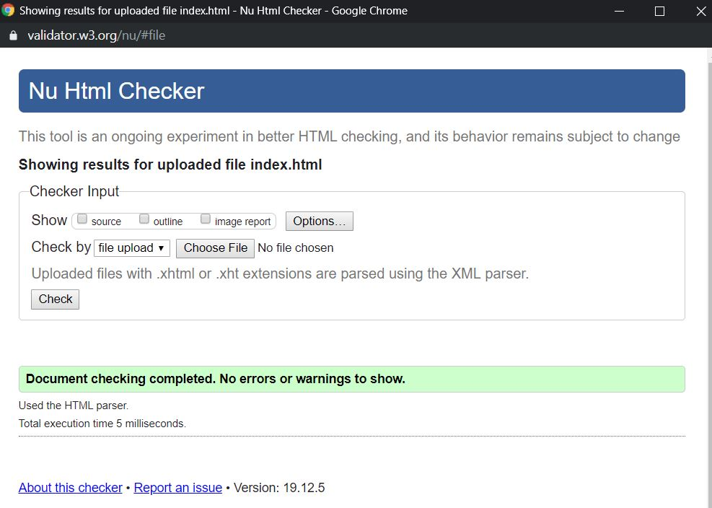
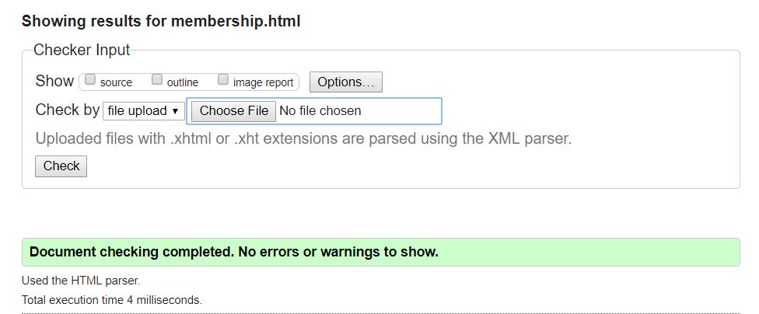

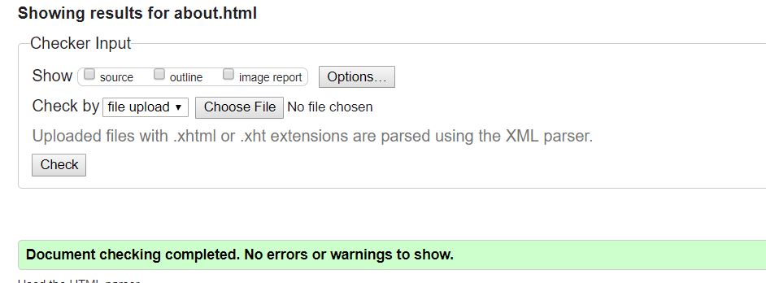

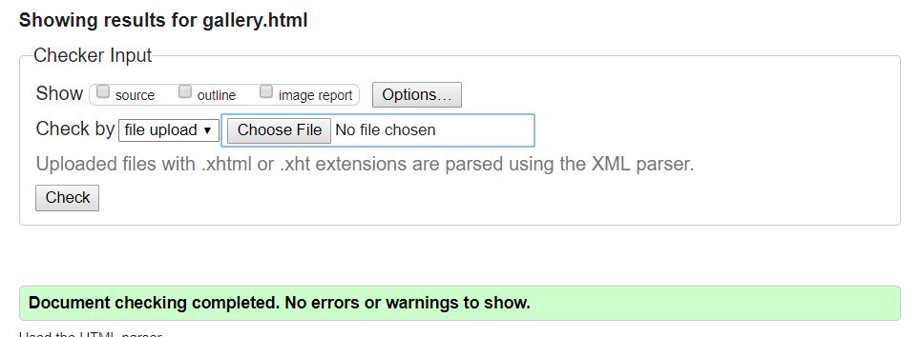

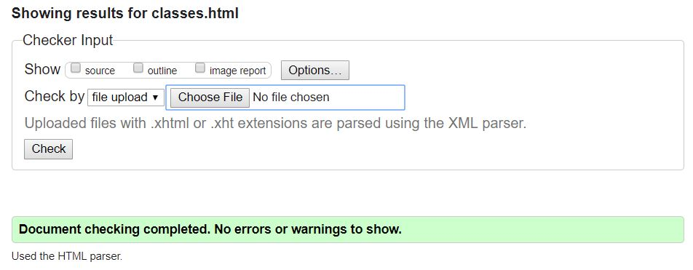

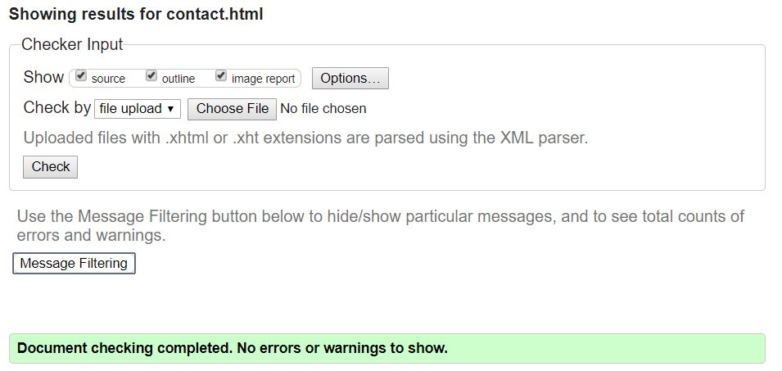

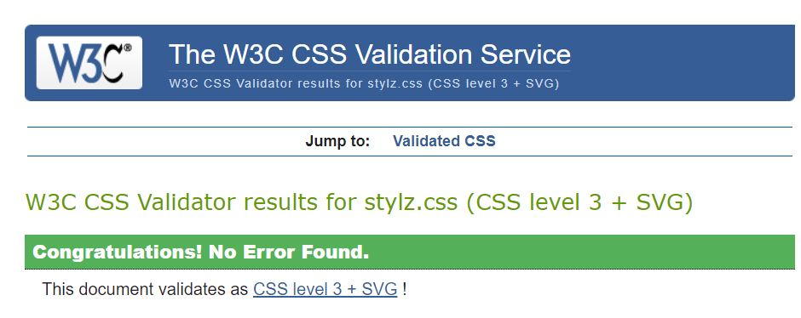

Section 3: Deployment

To deploy the website we tried to use GearHost. The attempt was unsuccessful and another host site was advised by another group, Netlify.

This website is more than easy to use.

https://demgainzgym.netlify.com/

Section 4: User Testing

I had a couple of my friends look at the website and here are their thoughts.

It’s very usable, it looks good. It’s attractive, exciting, great pictures and it is something that they would use. It looks like a decent gym website.

Some criticisms are that it could have a logo I the top left hand corner, the deals on the membership page could be interactive or there could be a form on this page to sign up or pay. The nav could be centred. There could be more pictures on the membership or the classes’ page.

There could be more text in the footer.

I understood where the criticisms came from but I felt for the purpose of our web page we did a very good job and I was pleased with our result.

Section 5: Project Team

Daniel and I felt that we could spit the project quite easily, coordination and allocation of tasks were done online through social media. We were always ready to take each other’s phone calls, plan, reassure each other and finally finish it off.
Dan began by working on the Index of the HTML and then sent it onto me. He then continued to create the other HTML pages. As he did this I worked on the CSS. When he had finished the skeleton of the HTML I did the CSS, then went into the HTML pages and fixed them to suit the new CSS. I then included the final 3 of the 4 JavaScript’s

Dan was always responsive, interested in the course, a good worker. I believe that we split the tasks 50/50, assigned tasks based on our necessity and preference.

As times got tough, we were calling each other every day, we did video calls to show our work live.
We stayed up a lot of late nights to have it finished in time.

I think he did a great job of this. He would do some HTML and send it over to me and I would keep working with the wireframe in mind. Bit by bit, piecemeal we got through it and I’m very happy with the result.

One big team issue would be that our team mate David dropped out of the course so a lot of plans went out the window and we had to concentrate our efforts, devise a new plan and advance from there. It was tough but we through our combined efforts we achieved our goal.

For help I examined the sample projects to give me an idea of the structure. I took some inspiration of the style from my research of the Fly Fit site and the usability of the Gold’s Gym. As I found things tough, I googled, went through the notes from this semester’s module and went on YouTube to help me understand the more complex aspects of the web design.

Section 6: Conclusion

I think the project went very well. It is always a little daunting working in teams on a new technology but we coordinated our efforts very well keeping in contact the whole time. I learned a lot from this project like how to approach a project like this with other people. Most importantly it was the first project where I felt like I was actually a developer. It has confirmed for me that this is an interesting, challenging and rewarding career move.

There were times that we panicked but, in the end, we rose to the challenge. We achieved what we set out to do. We created a user-friendly stylish web page for a tongue in cheek gym. It looks good and works very well. I am very happy with my work and that of my team mate. There are only 3 things I would change if I had more time.
- I might go back to centre the nav, as it might look better for this project.
- I would create a bigger footer with more content.
- I would put a logo in the top left corner.

These are all the things I would change if I had more time. Overall however I found it to be a very good first project. I appreciate all I have learned from this challenge and I am looking forward to the next one.

Section 7: References / Appendix

The photographs used were all taken from Pexels.com and all photos used do not require accreditation as per the web sites instruction.

